Figure 1 – StateGraph

V(StateGraph) = {Oregon, Alaska, Texas, Hawaii, Vermont, NewYork, California}

E(StateGraph) = {(Alaska, Oregon), (Hawaii, Alaska), (Hawaii, Texas), (Texas, Hawaii), (Hawaii, California), (Hawaii, New York), (Texas, Vermont), (Vermont, California), (Vermont, Alaska)}

1A. Draw the StateGraph

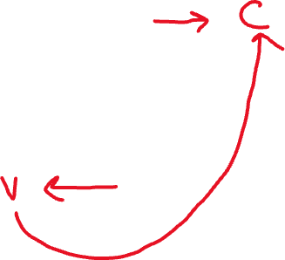

1. Is there a path from Oregon to any other state in the StateGraph There are no adjacent vertices starting at Oregon
2. Is there a path from Hawaii to every other state in the graph Yes, there are many paths
3. From which states in the graph is there a path to Hawaii Texas

3. Show the adjacency matrix that would describe the edges in the StateGraph. Store the vertices in alphabetical order

|  |  |  |  |  |  |  |  |
| --- | --- | --- | --- | --- | --- | --- | --- |
|  | A | C | H | NY | O | T | V |
| A | 0 | 0 | 0 | 0 | 1 | 0 | 0 |
| C | 0 | 0 | 0 | 0 | 0 | 0 | 0 |
| H | 1 | 1 | 0 | 1 | 0 | 1 | 0 |
| NY | 0 | 0 | 0 | 0 | 0 | 0 | 0 |
| O | 0 | 0 | 0 | 0 | 0 | 0 | 0 |
| T | 0 | 0 | 1 | 0 | 0 | 0 | 1 |
| V | 1 | 1 | 0 | 0 | 0 | 0 | 0 |

3. b. Show the adjacency lists

that would describe the edges in the StateGraph



|  |  |
| --- | --- |
| A |  |
| C |  |
| H |  |
| NY |  |
| O |  |
| T |  |
| V |  |



4 a. Which of the following lists the graph nodes (Figure 4) in depth first order beginning with E?

A) E, G, F, C, D, B, A

B) G, A, E, C, B, F, D

C) E, G, A, D, F, C, B



D) E, C, F, B, A, D, G

4 b. Which of the following lists the graph nodes (Figure 4) in breadth first order beginning at F?

A) F, C, D, A, B, E, G



B) F, D, C, A, B, C, G

C) F, C, D, B, G, A, E

D) a, b, and c are all breadth first traversals



5. Find the shortest distance from Atlanta to every other city



6. Find the minimal spanning tree using Prim’s algorithm. Use

0 as the source vertex . Show the steps.







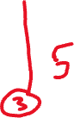

7. Find the minimal spanning tree using Kruskal’s algorithm.

Show the weights in order and the steps

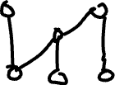

8. Find the minimal spanning tree using the algorithm you prefer. Use

Minneapolis/St. Paul as the source vertex

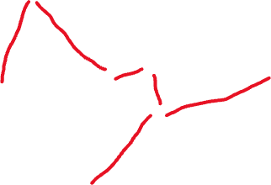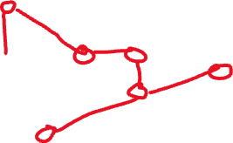

9. List the nodes of the graph in a breadth first topological ordering. Show the

steps using arrays predCount, topologicalOrder and a queue



|  |  |  |  |  |  |  |  |  |  |
| --- | --- | --- | --- | --- | --- | --- | --- | --- | --- |
| 0 | 1 | 1 | 3 | 3 | 2 | 2 | 0 | 2 | 2 |



|  |  |  |  |  |  |  |  |  |  |
| --- | --- | --- | --- | --- | --- | --- | --- | --- | --- |
|  |  |  |  |  |  |  |  |  |  |



|  |  |  |  |  |  |  |  |  |  |
| --- | --- | --- | --- | --- | --- | --- | --- | --- | --- |
| 0 | 0 | 0 | 3 | 2 | 1 | 1 | 0 | 2 | 1 |



|  |  |  |  |  |  |  |  |  |  |
| --- | --- | --- | --- | --- | --- | --- | --- | --- | --- |
| 0 |  |  |  |  |  |  |  |  |  |



|  |  |  |  |  |  |  |  |  |  |
| --- | --- | --- | --- | --- | --- | --- | --- | --- | --- |
| 0 | 0 | 0 | 2 | 1 | 0 | 1 | 0 | 2 | 1 |



|  |  |  |  |  |  |  |  |  |  |
| --- | --- | --- | --- | --- | --- | --- | --- | --- | --- |
| 0 | 7 |  |  |  |  |  |  |  |  |



|  |  |  |  |  |  |  |  |  |  |
| --- | --- | --- | --- | --- | --- | --- | --- | --- | --- |
| 0 | 0 | 0 | 2 | 0 | 0 | 0 | 0 | 0 | 1 |



|  |  |  |  |  |  |  |  |  |  |
| --- | --- | --- | --- | --- | --- | --- | --- | --- | --- |
| 0 | 7 | 1 | 2 | 5 | 6 | 4 | 8 | 3 | 9 |



10. List the nodes of the graph in a breadth first topological ordering.



1. Start
2. Discrete math
3. Programming 1
4. Programming 2
5. Computer Organization
6. Algorithms
7. Highlevel languages
8. Operating system
9. Compilers
10. Theory of computation
11. Senior Seminar
12. End